Whack-a-Robot

Analysis

Introduction and Outline
My idea for the project is based on whack-a-mole. This game will allow the user to control a “hammer,” which will be controlled with the arrow keys (now mouse after collecting information from stakeholders), to hit a robot which will appear at random intervals to increase their personal score. When the game is over the user’s score will be displayed and compared to previous scores. The software could be used by anyone but is primarily aimed at young people. This is because it aims to be a short piece of entertainment, to test the user’s reaction time and to compare scores to their friends as each score will be associated with a username; this means the program will serve a social purpose.
The reason I am making this project is because of its simplicity and depth. The experience of whack-a-mole being so well known it would not require explanation for the basics, but more ideas can be added to it. I am not sure of what added ideas would be suitable so further research must go into it. This simplicity will help shorten any aspects of development which may become overly convoluted because a simple game only needs a simple GUI, this takes away time from designing assets to more essential aspects like coding.
For it to be successful it must have understandable controls because it allows people to play it even if they are not very technologically literate. A clearly presented objective, luckily the objective of whack-a-mole is simple, hit the robot because it prevents the user from wasting time and not having fun. A self-evident interface because it means that what is occurring on screen will not require a text box to explain its purpose. To find out what this means I will both do research of successful examples of these and conduct interviews to find out what will work best.

Research
New Super Mario Bros. U Deluxe
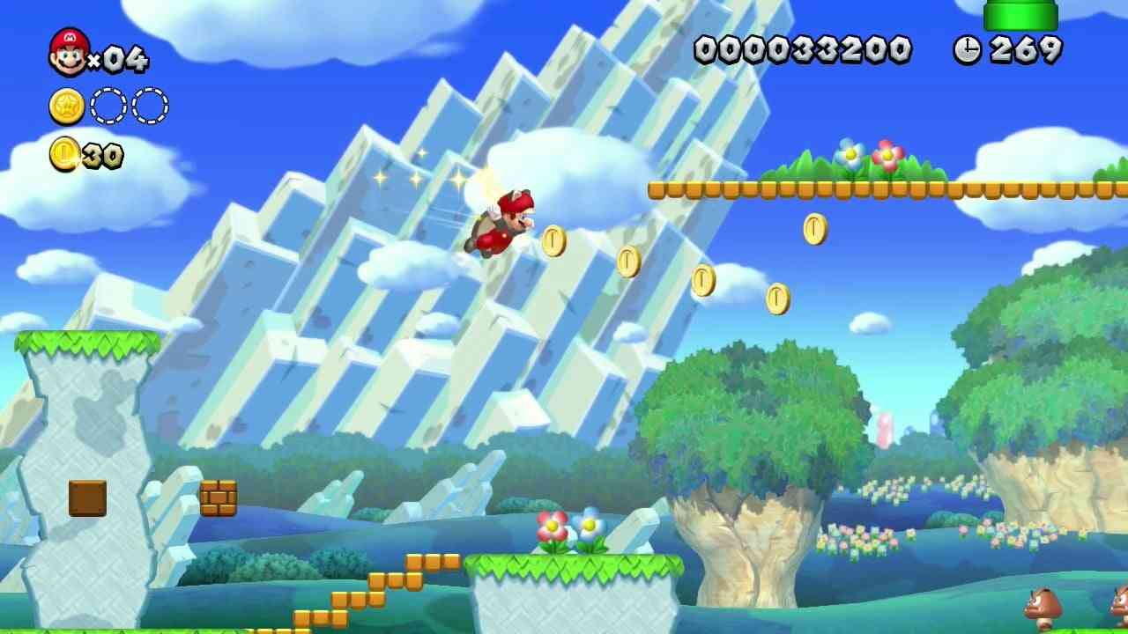https://cogconnected.com/review/new-super-mario-bros-u-wii-u-review/
New Super Mario Bros. U Deluxe is a 2D platformer from the Nintendo Switch with a stylised 3D art style. The games target audience are children and families because of its simplicity and family friendly art style.
What I will use | What I will discard
Easy to grasp UI because of the use of colour and symbols | The 3D art style because the game will not have a heavy focus on motion and animation like New Super Mario Bros. U Deluxe
Everything having a circular edge because it makes it easier on the eyes and more visually appealing to a younger audience | The explorable stage because the game will only consist of one non explorable stage with whack-a-robot.
The use of shapes, squares being objects and circular objects being characters, because it very quickly guides the player of what may interact with you or not. | Physics base movement because the gameplay for my game will be selecting where to hit your hammer and adding physics is unnecessary given the type of game.
The colour of objects, Mario is red, so he contrasts with the primarily green and blue background and the dull brown bricks both contrast with the background and natural environments to show they are interactable. This is because the use of colour will help draw the eye of the player to what is important to interact with.

Fun ‘N’ Games Whack a Clown
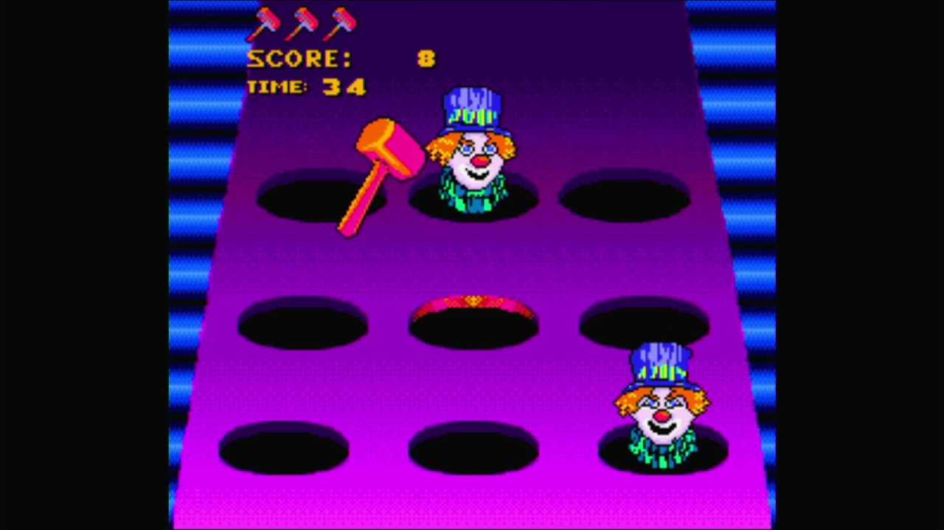Image taken from the thumbnail of this video https://www.youtube.com/watch?v=bMCpFmHgbX0 it came from this search fun ‘n’ games whack a clown gameplay sega genisis - Search Images
Whack-a-Clown is a Whack-a-mole knock off from the Sega genesis edition of Fun ‘N’ Games.
What I will use | What I will discard
The gameplay because it is a whack-a-mole clone so the base gameplay will be like what my game will have | The fake 3D perspective because a top-down perspective is more suited for my game. The reason for this is the aspect ratio will be wide so faking 3D will lead to a mass amount of unused screen space
An object to avoid hitting because it will add extra complexity to test the user’s reaction time. | The pixel art aesthetic because that is not something I know to draw so I will have the assets be hand drawn digitally.
The hammer being offset to the left of the selected hole because it makes it easier to see what is in the hole.

Fruit Ninja
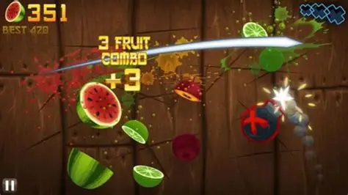
https://ar.inspiredpencil.com/pictures-2023/fruit-ninja-fruit
Fruit Ninja is a mobile and web browser where the player cuts fruits and avoids cutting bombs to increase their high score.
What I will use | What I will discard
The steak-based score system giving a combo multiplier because it rewards quick reaction timing which is the main point of the gameplay loop. | The type of punishment for hitting the wrong object would be different, in Fruit Ninja it is losing 10 points and a life, because in my game multipliers will go up too much higher than 10x so the multiplier resetting to 0 is punishment enough.
A penalty for hitting the wrong object because it will punish the player for acting too quickly. | Special objects that give more points because it will be complicated for the player to tell the values apart. This works in Fruit Ninja because value can be inferred by size, the smaller the harder to hit, but will not work in my game because all the player needs to do is select an area to hit
 | The added score being where the enemy object is hit because it will complicate the screen so the score increase will be shown with an increase the total score and the streak meter

Devil May Cry 5
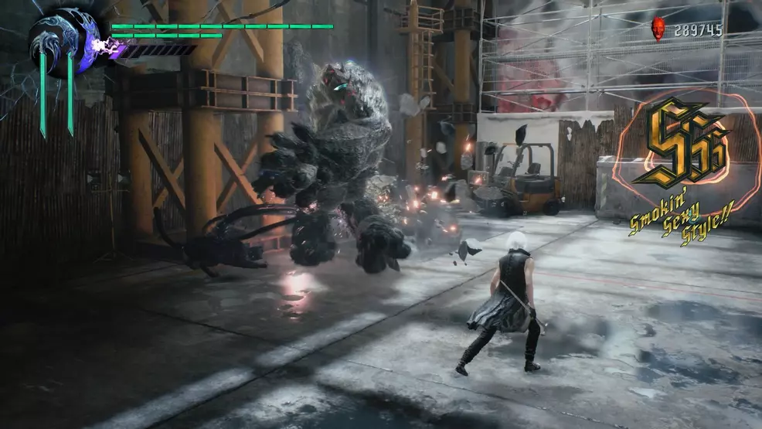
https://www.shacknews.com/article/110322/stylish-points-and-style-ranks-in-devil-may-cry-5
Devil May Cry 5 is an action game on modern game consoles and pcs.
What I will use | What I will discard
How well the player is doing, excluding score, having a visual indicator, in this example the style meter because it is an easy visual shorthand to the player of how they are performing in gameplay | The lettering system because in my game it represents the player’s current streak so it will just be a number with a “x” next to it to indicate it is a multiplier.
Each rank having a distinct colour because it will show instantly that the player has just improved without having to read the exact combo number.

Stakeholders
My stakeholders are teenagers of the ages 13-17. More specifically those who enjoy video games with simple reaction-based gameplay which they can challenge their friends to. This is because it has a short gameplay loop with a strict 2-minute time limit (up to change depending on survey result), so it benefits their busy schedule; each score will have a username assigned to it, so friends can directly compare scores and have a friendly competition with each other. The addition of an object you are not supposed to hit will add something for the user to look out for; this will be done to make the gameplay less repetitive to appease the short attention span of teenagers. This will make the game a fun little time waster while waiting for your next lesson or waiting for and travelling on public transport.
Given the I anticipate people will play this game while waiting for something I will do a survey to find out the optimal time limit. This may result in the addition of a pause button.
I hope to include stakeholders in market research and early testing because this is before there have been any major commitments to development so changes will be easier to implement without having to redo previously written code.
The survey results are indicative of my target audience because I sent the survey to fellow year one students at BHASVIC who are of the ages 16 to 17.

Survey analysis
Q1: What is the most important part of a game when playing it.
The purpose of this question was to find out what my stakeholders found most important. This has been done so I know what is most important to focus on during game development.
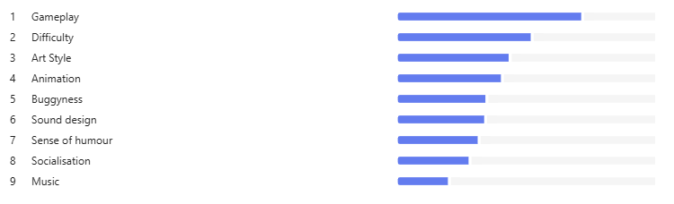
The results show that the surveyed stakeholders overwhelmingly prioritise gameplay (100% put it as their first option). This means that I should primarily focus on the gameplay being fun and responsive. The second being difficulty I will need to focus on the game having a tough challenge, I will implement difficulty with there being a tight window to hit the robot and have there be visual indicators of when the player is doing badly. The emphasis the stakeholders have on Art Style will mean I will have to spend time making the game visually appealing and the quality of the visuals being achievable in the timeframe I have; this will also impact what needs to be done with animation given how both aspects are interlinked during development and the stakeholders view both being of similar importance. For music and sound design, something the stakeholders view as less important, instead of creating them myself I will find free to use sound effects and music online which fit the tone of the game. For ‘Sense of humour’ I will not prioritise because it is both low in the ranking and highly subjective, so what I will do is make the game silly so people will recognise the intended tone. The low ranking of socialisation features means that score boards are not important to the stakeholders and that I should just focus on displaying only the current score and high score because the research has shown that stakeholders do not view competing against each other as being important.

Q2: How often do you play casual "reaction-based" or arcade games?
The purpose of this question was to find out if my stakeholders were familiar with the genre of game I am creating. 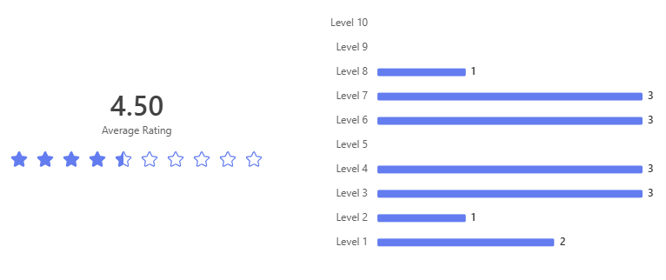
1 is for no and 10 is for yes.

The survey shows that my stakeholders are overall not familiar with the genre of game I am making. This means many of the concepts are unfamiliar to them. Because of this I will need to make a functional ingame tutorial explaing the mechanics to the player. However a good number of them are familiar with the genre. To solve this I will have the tutorial be accessible from the menu. This will allow for two things: 1 – it will allow players to revisit the tutorial if they are struggling to understand the gameplay and the mechanics and 2 – it will allow experienced players to skip the tutorial and get straight to playing the game.

Q3: In an arcade style game, which type of difficulty do you find most fun?
The purpose of this question was to collect data what the different types of difficulty the users would find fun.
This is the word cloud: 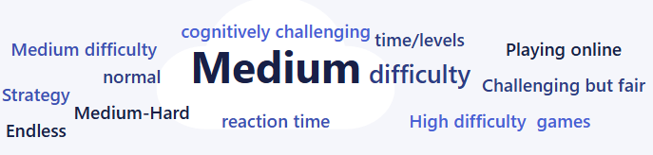
This is the full tabel of answers:
- Medium to High difficulty
- Medium
- Medium-Hard
- Medium
- Strategy/Increasing difficulty over time/levels
- normal
- reaction time based games
- Medium difficulty so it keeps me playing
- hard
- hard
- normal
- dont know
- cognitively challenging
- Endless or increasing levels
- Challenging but fair
Some responses can be disregarded like an endless mode, because having a strict time limit is a feature of my game and this applies to all level-based responses. Most answers are the level of difficulty the stakeholders want. This alongside another question will inform the level of difficulty that would most satisfy my stakeholders. The main responses of this sort are between normal/medium to hard. This will have implement elements that make the core gameplay more difficult like items that you are not supposed to hit.

Q4: What is a preferable control scheme for a whack a mole base game on computer?
This was done to find out what control scheme would work best for the stakeholder.
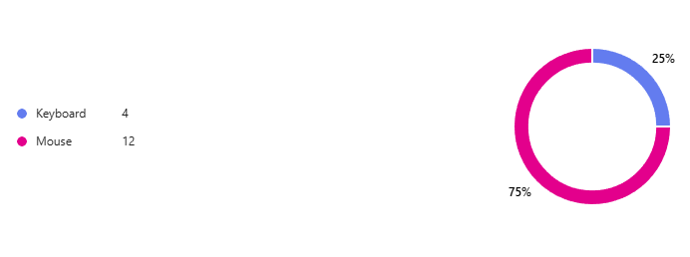
This shows that 75% of the stakeholders would prefer to play with a mouse instead of a keyboard. This means that I will have to have the gameplay be very much based on quick reaction times. This is because you can navigate quicker across a screen with a mouse instead of a keyboard. As a result, of this the timing window for the robots will be shorter than I originally intended. However, the ¼ of people who prefer a keyboard are still important so there will be an option to switch control schemes; mouse will be set as the default opt in option.

Q5: Do you think being punished is good? (in gaming)
The purpose of this was the find out if there should be a heavy punishment for failure.
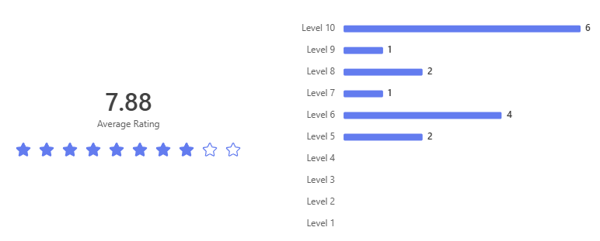
As shown by the graph most people think that it is a particularly good thing (everyone rated the idea as being above 5). This means that the “style meter” keeping track of the user’s combo must be included because it is a massive visual indicator of where they went wrong, adding a sound effect may also help this feeling. Because there is no health system the only way to punish the player is to either limit the score or make them really feel like they have made a mistake.

Q6: What additional feature(s) would make whack-a-mole more fun as a video game?
The purpose of this was to find out if there were any additional features the stakeholders specifically wanted.
This is the word cloud:
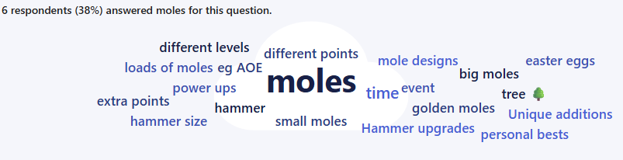

Individual Answers:
- Skill tree 🌳 / different levels with gimmicks or themes
- Unique additions e.g. power ups that increase the hammer size
- A score so you can attempt to beat personal bests
- Not sure
- Hammer upgrades eg AOE or speed
- objects that you need to avoid hitting, golden moles for extra points
- quicker pop up time
- maybe power ups that let you hit more moles at once, or a timed event where loads of moles pop up at once like in fruit ninja
- having funny characters as moles
- Different mole designs for different points
- add some easter eggs like if you hit a mole 5 times in 1 second it turns blue or sm
- bombs that you should not hit
- big moles, and small moles.
- Customisation
- Random events

Additional features are very popular with the stakeholders. Especially their being “moles” have given you a different score and their being objects you are not allowed to hit. The offer ideas will be put down as desirable elements because they are not necessary to the core of the gameplay.

Q7: Do you find audio cues important?
The purpose of this was to decide if adding audio when a robot shows up benefits the stakeholders experience
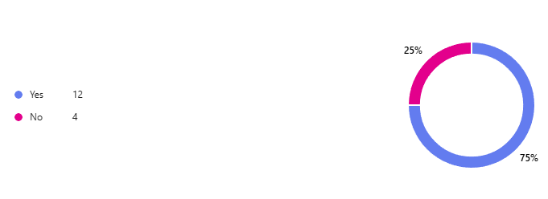
Given the results the feature will be added due to 75% of stakeholders finding it an important feature. Even though 25% of stakeholders find it unimportant adding audio cues does not detract from their enjoyment of the game.

Q8: What are some accessibility options do you think would be nice if they were implemented?
The purpose of this was to collect data on possible accessibility options that could be a benefit to stakeholders that I could not come up with due to me being able bodied.
Word cloud:
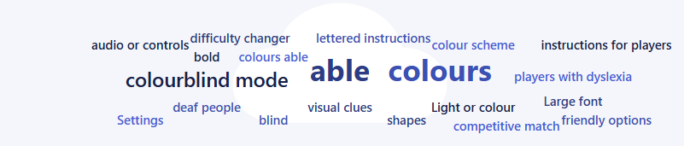
Full answers:
- Settings to allow you to change / adjust audio or controls
- Not sure
- Clear bold lettered instructions for players with dyslexia.
- being able to control if you want the music on or off.
- Large font, anything that needs colours able to use shapes instead
- .
- difficulty changer
- colourblind mode and maybe visual clues for deaf people
- colour scheme
- TTS
- idk
- dunno
- maybe color blind friendly options
- Light or colour indications
- Colourblind mode
Most of the answers, which were not a variation of no answer, were accessibility features for people who are colour blind or have dyslexia. To address this, I will ensure the colour scheme is suitable for those who are colour blind or have dyslexia and give options to turn them on or off and customisation features to best suit the player’s wants and needs.

Q9: How long do you think each round should be?
The purpose of this was to what time limit would be suitable for most of the stakeholders. The one with the greatest number of votes would be selected because having multiple time limits would mess up the score system.
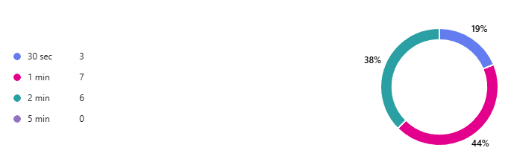
This is the most split of the votes. I will have to choose a one-minute time limit because it is what the highest percentage of the stakeholders want. It will only be a one-minute timer because having multiple time limits would make the score redundant because the more time you have the higher score you can get. This will annoy many of the stakeholders but not all of them equally. The 38% that chose two-minutes would be less affected because they clearly have time to do one-minute; the 19% that chose 30 seconds would be negatively affected.

Q10: How should a pause mechanic work?
This question had two purposes: one was to find out if people wanted the ability to pause the game; and two was to find out what type of pause menu the stakeholders would want if the minority voted for no pause screen. 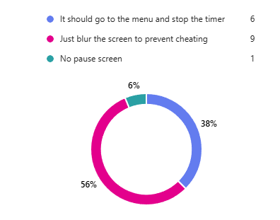
The results show that the majority want a pause screen; and that the type of pause screen would be one that blurs the screen to prevent people just pausing the check what positions the robots are. This option was chosen by 56% of players.

Requirements

 | Feature | Description |  | Measurement | Justification | Importance
1 | Controlling the hammer with the mouse. | Being able to control the main object, the hammer, with a mouse to move it around the screen and use it to hit the robots. | a | Having the hammer sprite be attach to the mouse’s movements. | This is a feature because it is the main way the player interacts with the game and it needs to be able to detect if a robot has been hit for the score system to work. | Required
1 | Controlling the hammer with the mouse. |  | b | On a left click play an animation of the hammer smashing. |  | Required
1 | Controlling the hammer with the mouse. |  | c | To detect if the hammer is smashing a robot or not. |  | Required
2 | The robots popping out a hole. | Every few seconds one or more robots will pop out a hole which is displayed on the screen, and they will renter their hole after a few more seconds if they are not hit. | a | One or more popping out of a hole every few seconds | This is a feature because there needs to be an enemy for the player to interact with. The features with the score exist to add punishments and rewards for hitting or not hitting the robots. | Required
2 | The robots popping out a hole. |  | b | When they are hit with the hammer, they disappear. |  | Required
2 | The robots popping out a hole. |  | c | If they are not hit after a few seconds, they disappear. |  | Required
3 | A Main Menu | At the start of the game there is a main menu with multiple options on what you can do | a | A start button | This is a feature because there must be some way to exit the game and to view their achievements; and to start the game with an option and it not being automatic so the user will have time to process what they are about to do. | Required
3 | A Main Menu |  | b | A quit button |  | Required
3 | A Main Menu |  | c | A piece of text showing the user’s high score |  | Required
4 | Score System | A variable which is updated depending on how well the player is doing | a | For it to be updated as you hit robots | The reason I am including this is because it directly tells the user how well they are doing and how much better/worse they are doing compared to previous rounds. | Required
4 | Score System |  | b | For the current score to be viewable as it is being updated as you play the game |  | Required
4 | Score System |  | c | For the user’s current high score to be visible in both the game and the main menu. |  | Required
4 | Score System |  | d | For the score to be updated when the player hits the robot. |  | Required
5 | Timer | An in game one-minute timer which results in a game over when it reaches 0 seconds. | a | For the timer to count down by one each second | This is a feature because it will add pressure to the user by adding a strict time limit. This also assists it being something people would do in their spare time due to the shortness of each round. | Required
5 | Timer |  | b | For the timer to be visible in game |  | Required
5 | Timer |  | c | When the timer reaches 0 the game ends |  | Required
6 | A pause menu | The user will be able to pause the game using a click of the mouse | a | When the user right clicks the game pauses. | This is a feature because it will allow the player to stop the game if they need to do something else. The blur is required to stop the player from cheating by pausing the screen to check where the robots are and then unpause to hit them. | Not required
6 | A pause menu |  | b | When the user pauses the game, the screen blurs. |  | Not required
6 | A pause menu |  | c | The timer will also pause |  | Not required
6 | A pause menu |  | d | The players current score will also be viewable. Non-blurred. |  | Not required
7 | A combo system | When a player hits one robot after another without missing a hit, the next score increases by a multiplier. | a | The multiplier starts at 0 and after each hit the multiplier increases by one | This is a feature because it adds both a mechanical and visual signifier of how well the player is doing. It being a combo that is broken by making a mistake reinforces the emphasis on reaction time. Another purpose of the multiplier is too visual indicate to the player when they make a mistake and for it to take time for them to reach their previous multiplier. | Not required
7 | A combo system |  | b | The multiplier has a max of 16 |  | Not required
7 | A combo system |  | c | There is a visual signifier of the current multiplier |  | Not required
7 | A combo system |  | d | The visual signifier will look different at each multiplier |  | Not required
8 | Bombs | They operate like the robots but if you hit them, you lose points from your score, the combo resets and you cannot move the hammer for 2 seconds. | a | Needs to pop out the holes at random intervals, but a lot less than the robots. | This would be done to make the game more challenging. This is done because most of the stakeholders like being punished in games. | Not required
8 | Bombs |  | b | When they get hit there needs to be a visual signifier to show that the score has decreased |  | Not required
8 | Bombs |  | c | When hit the combo resets. |  | Not required
8 | Bombs |  | d | When hit the user cannot move for 2 seconds. |  | Not required
9 | Distinct types of robots | There will be different robots of varied sizes and colours. The size will affect the number of points given. | a | There being distinctive looking sprites | This would be a feature due to stakeholder demand to add extra difficulty by having the user look out for different more rewarding robots to hit | Wishful
9 | Distinct types of robots |  | b | The smaller the sprite the more points they get |  | Wishful
9 | Distinct types of robots |  | c | They disappear faster |  | Wishful
10 | Music | Different music tracks on menu and gameplay | a | Two unique music tracks | It would be included due to the stakeholders ranking it very differently, so it is divisive. This means for some it is high priority but most it is low. This feature will add extra engagement by making it more entertaining. This is because without music a game can be quite dull | Wishful
10 | Music | Different music tracks on menu and gameplay | b | Change depending on if you are in the menu or game |  | Wishful
11 | Sound Effects | When an action occurs a sound effect plays. | a | A sound plays when the user hits the robot | This is a feature because it adds an audio cue when something happens. This is popular with the stakeholders, and it helps the user understand what is currently occurring in game. | Not required
11 | Sound Effects | When an action occurs a sound effect plays. | b | Sound plays when a robot appears |  | Not required
11 | Sound Effects | When an action occurs a sound effect plays. | c | Sound plays when a bomb is hit |  | Not required
11 | Sound Effects | When an action occurs a sound effect plays. | d | Sound plays when the player does not hit a robot |  | Not required
11 | Sound Effects | When an action occurs a sound effect plays. | e | Sound plays when player selects to play the game |  | Not required
12 | Accessibility features | Extra settings for people with audio visual difficulties | a | An extra option on the main menu to turn the options on and off | This would be a feature because it will allow more people to enjoy the game. These specific options are important because the game’s difficulty relies heavily on the user's audio and visual senses and it would be unfair for people who have disabilities to not be able to enjoy the game. | Wishful
12 | Accessibility features | Extra settings for people with audio visual difficulties | b | Clear bold lettering for people with dyslexia |  | Wishful
12 | Accessibility features | Extra settings for people with audio visual difficulties | c | Options to change the colour scheme for colour blind people |  | Wishful
12 | Accessibility features | Extra settings for people with audio visual difficulties | d | An extra visual signifier in place of sound effects for people hard of hearing |  | Wishful
13 | Multiple users | Can create a profile and compare it with other profiles | a | Can assign a name | The purpose of this is to have a direct competition between users | Wishful
13 | Multiple users | Can create a profile and compare it with other profiles | b | Name put before high score |  | Wishful
13 | Multiple users | Can create a profile and compare it with other profiles | c | Button in menu to create or switch user profile |  | Wishful
14 | Keyboard control scheme | User can switch to controlling hammer with a Keyboard | a | Can switch control scheme in options menu that can be accessed from the main menu | The purpose of this is to allow there to be additional control methods to appease the sizeable portion of stakeholders that would have preferred to control the hammer with the keyboard. | Wishful
14 | Keyboard control scheme | User can switch to controlling hammer with a Keyboard | b | Move the hammer’s position with the arrow buttons |  | Wishful
14 | Keyboard control scheme | User can switch to controlling hammer with a Keyboard | c | Play hitting animation and collision with the space key |  | Wishful

Limitations
Limitation | Explanation
Multiple users | Given the time of having a system to create and save data of multiple users and a system to create or switch users could be better allocated to more essential features. The reason I do not consider it an essential feature is the lack of demand for it among the stakeholders
Accessibility | This will take a lot of time to implement most of the elements, time that could be dedicated to essential features. The parts that would take time would be the extra menu, colour blind options and creating extra visual signifies. The reason this is not essential is because most people do not have audio visual difficulties.
Music | Finding and implementing multiple music tracks will be time consuming. It is ranked low in what the stakeholders find important. The time required would be better spent making sure the game is play able and fun.
Different Robots | Even though some code can be reused the creation of entirely new assets takes time that could be better spent elsewhere. It is this low priority because of low stakeholder demand, and it is not necessary to the minimal viable product.
Keyboard control scheme | Even though it would make a sizable portion of stakeholders upset the drawbacks of implementing it would be too great. For example, the rate moles pop up would have to change because it is slower for the player to navigate using only the arrow keys. Also implementing an entirely new control method would simply take too much time that could be better spent improving the most popular control scheme.

Hardware and Software requirements
Hardware:
- Speakers for sound affects
- A mouse for inputs
- Not likely to need a large file size or a large amount of memory
- The computer does not need to powerful it just needs a CPU and GPU that is not weak
- Needs to be a general-purpose computer
- Specific requirements (taken from System requirements — Godot Engine (stable) documentation in English more specifically the minimum requirements)
  - CPU: x86_32 CPU with SSE2 support, x86_64 CPU with SSE4.2 support, ARMv8 CPU
  - GPU: Integrated graphics with full Vulkan 1.0 support
  - RAM: 4GB
- The reason why it is the minimum requirements is that my game will not take advantage of Godot's 3D features which are included in the requirements. This means listing Godot's minimum requirements is a safe bet on what my game’s requirements will be.

Software:
- The operating system needs to be windows because Linux would require extra .NET software
- Windows 10 (also from System requirements — Godot Engine (stable) documentation in English minimum requirements)

Computational Approach
This can only be done using a computational approach for five reasons:
- It requires multiple operations to run concurrently, player movements, enemies' position, timer, score, streak and object collision between the player and enemies. All operations must occur at the same time for the game to be functional to the player. This can only be done using a computer because handling all variables would be too much for one person.
- Decomposition, breaking one big section into multiple smaller sections, will be used because the programming language I will be using is c# which is object oriented. This makes the program more manageable by giving each competent their own separate script. To plan this, I will create a structure diagram.
- I will use abstraction to remove any unnecessary details. This is because my game is an abstraction of a real-life physical game. This means detail like physics will be removed due to the game being made in 2D. Only details important to the player will be shown, like the player’s and enemies’ position, timer, streak, and score.
- I will use performance modelling to discover if the game will run as expected. This is required so the players do not have to encounter any situations where the game does not run as expected.
- Will use visualisation to plan the programming to find out the best way to solve problems. I will use flowcharts to plan the algorithms so I can make sure the logic being used is sound before starting to code.

Development Plan

Structure diagram
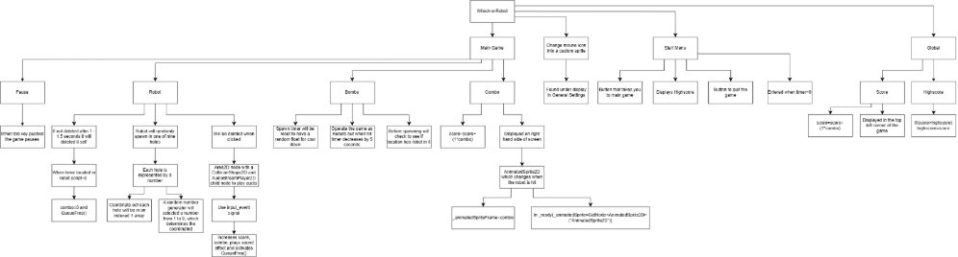
Explanation:
This structure diagram contains all features in the program and how the work. For example, Robot has an explanation of what will happen when it is clicked and how I intend to do this with some basic programming logic. It is structured in layers of significance. For example, on the 1st/top layer it is the whole game, and the 2nd layer is each scene, the 3rd layer is the objects in each scene and 4th layer and downwards is features and explanations.

Justification:
The reason why there is a structure diagram is so I can see how all the features connect to each other and it is a visually concise way of seeing all of the features I need to implement; without having to go through a list of them. It is structured in layers because it is easier to read and decipher how important something is in relation to everything else; the lower layers relate to the upper layers.

Stage 1: Nodes and Scenes:
Before any feature or code can be added all required nodes and scenes for the project and the creation of an initial data dictionary for all the unique node names and categorize them by the scene they are in. This is done first because it means that everything that is essential to the project is created and organized. It will also make creating the required signals more straightforward.
Test No. | Description | Test data | Expected Result | Justification | Actual result
1 | Are all the correct scenes there? | Open program editor | All correct scenes have been created | To make sure there will not be any extra scenes that need creating
2 | Are all the correct nodes there? | Open each scene in program editor | All scenes have the correct nodes | To make sure there will not be any extra nodes that need creating
3 | Are all the scenes and nodes in the data dictionary? | Open each scene in program editor and compare to data dictionary | All scenes and nodes are mentioned and categorized in the data dictionary | To make sure that proper organisation has begun and won't need to be created later

Stage 2: The Skeleton:
I intend to do this first because these features are essential for a working minimum viable product and, excluding score, other extra features build off the core of the game. This means that these must be completed first. Visuals in this section will be differently coloured rectangles as placeholder assets until the actual assets have been made.

Stage 2a: Start menu:
Creating a start menu that allows the user to exit and be able to start the game and having a basic description of the controls and how to play the game.

Stage 2b: Robot:
Creating the script for the user being able to interact with robot and the robot randomly appearing in one of nine holes every second, which it will disappear if not hit (to make it easier to debug increase time limit).

Stage 2c: Timer
A one-minute timer which will be displayed in game. The timer will be 60 seconds as a float and when it reaches 0 the scene will change to the main menu where the score is displayed.

Completes the following success criteria:
- The robots
- A Main Menu.
- A timer

Tests:
Test No. | Description | Test data | Expected Result | Justification | Actual result
1a | Can the user enter the game from the “start” button? | Run program and press the “start” button | A scene change to the “game” | To test if the buttons work and that file location of each scene has been recorded properly
1b | Can the user quit the game with the “quit” button? | Run program and press the “quit” button | The program closes | To test if the quit button successfully closes the program
1c | Is the text describing controls and how to play the game shown? | Run program | The text describing controls and how to play the game is shown | To check if text objects can be displayed correctly.
2a | Does the robot spawn? | Run program and press the “start” button | A new instance of the robot is created | To test if there are no logic errors in the code the spawns the robot
2b | Does the robot spawn in one of the nine holes? | Run program and press the “start” button | The robot should appear in one of nine holes randomly | To test if the random number generator and coordinates work together correctly
2c | Does the robot disappear when clicked? | Run program, press the “start” button and click the robot | The robot disappears when clicked | To test if the mouse can interact with non-button objects
2d | Does the robot disappear after the number of seconds determined? | Run program and press the “start” button | The robot disappears after the determined number of seconds | To test if the robot's internal timer works correctly
3a | Does a 60 second timer appear? | Run program and press the “start” button | Timer appears and decreases value by 1 each second | Can the timer variable be displayed correctly and decrease accurately to real life
3b | Does the timer work? | Run program, press the “start” button and wait 60 seconds | When timer reaches 0 you get taken back to the start menu | Does the logic that changes scene when the timer=0 work

Stage 3: Score and timer:
This will be done next because Score is affected by the user’s interaction with the robots, so cannot be done before. This is done before other features like pause button and objects to avoid is because those features are not necessary.

Stage 3a: Score:
Create a score variable, which is updated when the player successfully clicks on a robot.

Stage 3b: High Score
A high score variable that is displayed on the main menu

Completes the following success criteria:
- Score
- Timer

Tests
Test No. | Description | Test data | Expected Result | Justification | Actual result
1a | Does a score number appear? | Run program and press the “start” button | The integer 0 appears | To check if the text object has properly connected with the global integer for score
1b | Does the score number increase when interacting with the robots? | Run program, press the “start” button and click the robot | The score increases by 5 | To check if the global integers can be updated by the actions in the game scene
2a | Does high score appear on the start screen? | Run program | High score appears with the value of 0 | To check if the text object has properly connected with the global integer for high score
2b | Is high score accurate? | Run program, press the “start” button, click the robot once and wait for timer to end | High score has a value of 5 | Can the score variable displayed as text correctly
2c | Can the high score be updated? | Run program, press the “start” button, click the robot once and wait for timer to end. Press “start” button again, click two robots and wait for timer to end | At end of first game high score has value of 5, at end of second game high score has value of 10 | Can the score variable be updated correctly

Stage 4: Extra:
These features are done last because I have categorized them as not required, this means it would be nice if I could implement these features, but they are not essential to the minimum viable product, so they are done last.

Stage 4a: Pause button:
Create a pause button. When pressing the escape button on the keyboard, the game pauses.

Stage 4b: Bomb:
A bomb object to avoid. If the player clicks on a bomb the combo will reset to one and the timer will decrease by 5 seconds.

Stage 4c: Sound effects:
Sound effects will play when a bomb or robot is hit, this will be different depending on the object hit.

Stage 4d: Multiplier:
A score multiplier that is shown and updated when interacting with a robot. For multiplier to work it will have it be an AnimatedSprite2D so each number can look slightly different and must be able to be reset if the player misses the robot or hits a bomb. Hitting a robot increases the value and appearance of the multiplier.

Completes the following success criteria:
- Bomb
- Pause button
- Combo/multiplier
- Sound effects

Tests
Test No. | Description | Test data | Expected Result | Justification | Actual result
1 | When tab key pushed the game is paused? | Run program, press the “start” button and press the tab key on keyboard | All game operations pause; this can be checked with the timer | Does the program allow non-mouse inputs and does the pause code work correctly
2a | Does a score multiplier appear? | Run program and press the “start” button | The sprite frame for 1 appears | Can the score multiplier appear and has the first sprite frame been loaded correctly
2b | Is the score multiplier accurate? | Run program, press the “start” button and click the robot | The score multiplier changes to the sprite frame for 2 | Can the multiplier be updated and is the value of the multiplier connected to the second sprite frame
2c | Does the score multiplier increase when interacting with the robots? | Run program, press the “start” button and click two robots | On the first click of the robot the score will increase by 5 and on the second click it will increase by 10 | Does the multiplier effect the score correctly, the score should update before the multiplier
2d | Does the score multiplier decrease when failing to interact with the robots? | Run program, press the “start” button and click one robot and wait for the next one to disappear | On first click the score multiplier increases to 2 and after second robot disappears the score multiplier decreases to 1 | Is the multiplier effected by not interacting with the robot
3a | Does the bomb spawn? | Run program and press the “start” button | A new instance of the robot is created | Can the code from robot be copied over to bomb and are there any conflicts
3b | Does the bomb spawn in one of the nine holes? | Run program and press the “start” button | The robot should appear in one of nine holes randomly | To see if bomb operates the same as robot and if they both try to spawn in the same hole
3c | Does the bomb disappear when clicked? | Run program, press the “start” button and click the robot | The robot disappears when clicked | Has the interaction logic from robot been transferred correctly
3d | Does the bomb affect the timer and multiplier | Run program, press the “start” button, click the robot then click the bomb | Timer decreases by 5 and multiplier changes to 1 | To check if global variables be affected in the bomb object
3e | Does the bomb disappear after the number of seconds determined? | Run program and press the “start” button | The robot disappears after the determined number of seconds | To check if the internal timer on the bomb is working correctly
4a | Do sound effects play when robot is hit? | Run program, press the “start” button and click the robot | The selected sound effect plays when the robot is hit | To check if the sound effect has been loaded correctly for robot
4b | Does a different sound effect play when bomb is hit | Run program, press the “start” button and click the bomb | The selected sound effect plays when the bomb is hit | To check if the sound effect has been loaded correctly for bomb

Step 5: Graphics:
This will be the art assets which will be created by me. The assets included will be the mouse, which will be changed to a hammer; the robot; the bomb; the background; all 16 stages of the multiplier. These will be made in my spare time all throughout development, the combo one will be made first due to it having an animated sprite 2d.

Completes the following success criteria:
- Controlling the hammer with the mouse

Tests
Test No. | Description | Test data | Expected Result | Justification | Actual result
1 | Do the characters have the correct assets? | Run program and press the “start” button | All characters have the correct assets | So, there is not any visual error that might confuse the user.
2 | Does each multiplier stage have the asset associated with each number e.g. 1, 5, 16? | Edit the initial value of the multiplier in the code. Run program press the “start” button. Increase value by one each test until all sprite frames have been tested. | All multiplier values have the correct assets. | To check if all the frames for multiplier have been put in the correct order.

GUI

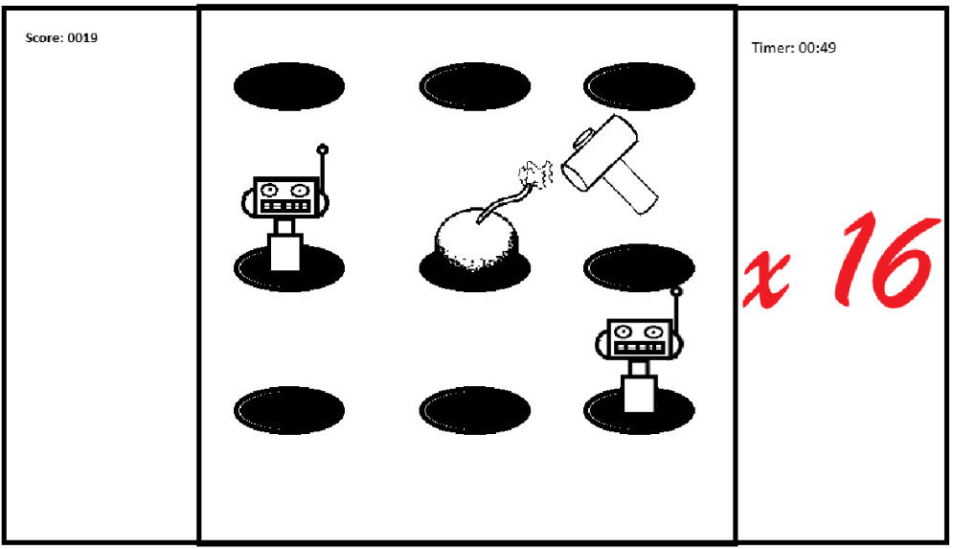
(This current GUI is a mock up and will not represent the final game, in its completed form it will resemble the art style referenced in the research section in analysis)
This is the multiplier/combo. Each number will have a different and unique design, so the user can instantly differentiate each number immediately without checking the number too closely, this is why it is the only object in colour in this GUI.
This is the hammer that is controlled by the mouse. This interacts with the robots and the bomb by having the user click them.
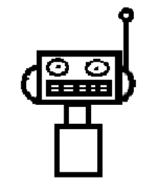This is the robot, which the player clicks on to earn points. When clicked it disappears but also disappears if not hit for 1-1.5 seconds.
This is one of the holes. It is not an object but just a part of the background so it is non-interactable the only important thing about it is that the coordinated of each one is where a robot/bomb might pop out. There are 9 in total in a 3x3 layout.
This is a bomb. It operates like the robot, but when it is hit the timer automatically decreases by 5 seconds.
This is the current user score updated when the robots are hit. If it is higher than the high score the high score is replaced with this. Equation for score: score=score+(1*combo)
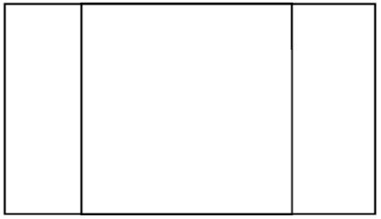This is the background format without any extra details. It is a 16:9 rectangle because that is the most common monitor format and this game will be played on computer monitors. The inner square is where the game is played and contains all the important info the player needs to be actively concentrating on. Extra info like timer, score and multiplier are outside square in the player’s peripheral vision because it is not immediately important to the player.

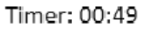This is the timer. It is a 60 second timer that usually decreases by one per second but if the player hits a bomb it will decrease by five seconds.

Development

Stage 1:

Design:
Given the nature of this stage is creating the required nodes or scenes and does not require any programming I do not believe pseudocode and flow charts are not necessary. I will also not need to create a data dictionary for this stage because this stage involves the creation of a data dictionary, but what will need to be created is a step-by-step chart. I have decided to make it a GitHub repository so I can access the project from outside of school.
This is the chart:
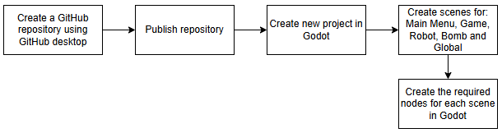

Development:
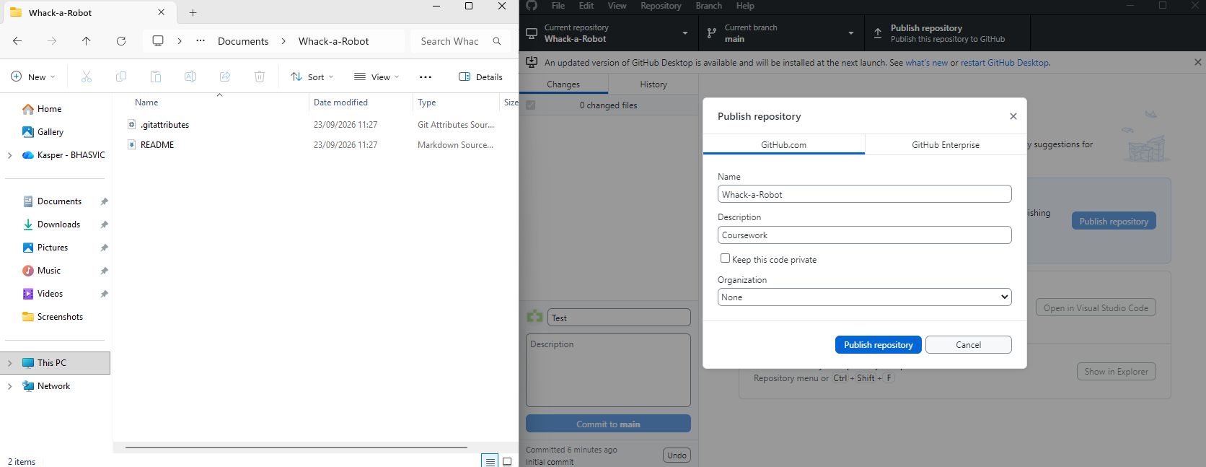
Repository successfully created on school computer.

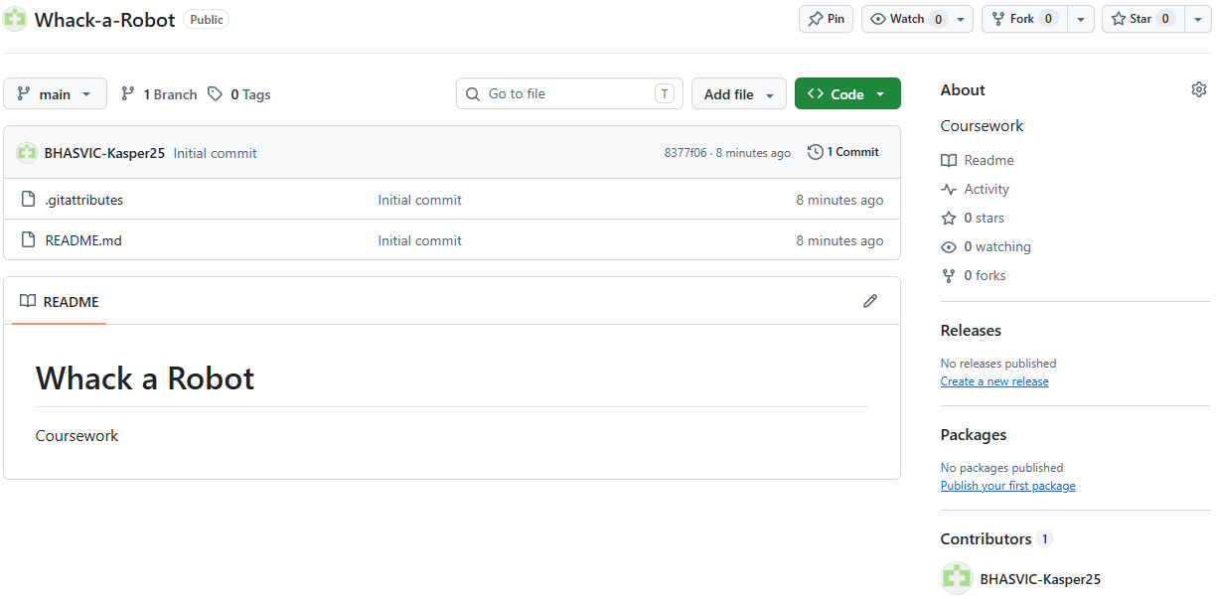
Repository now accessible from online.
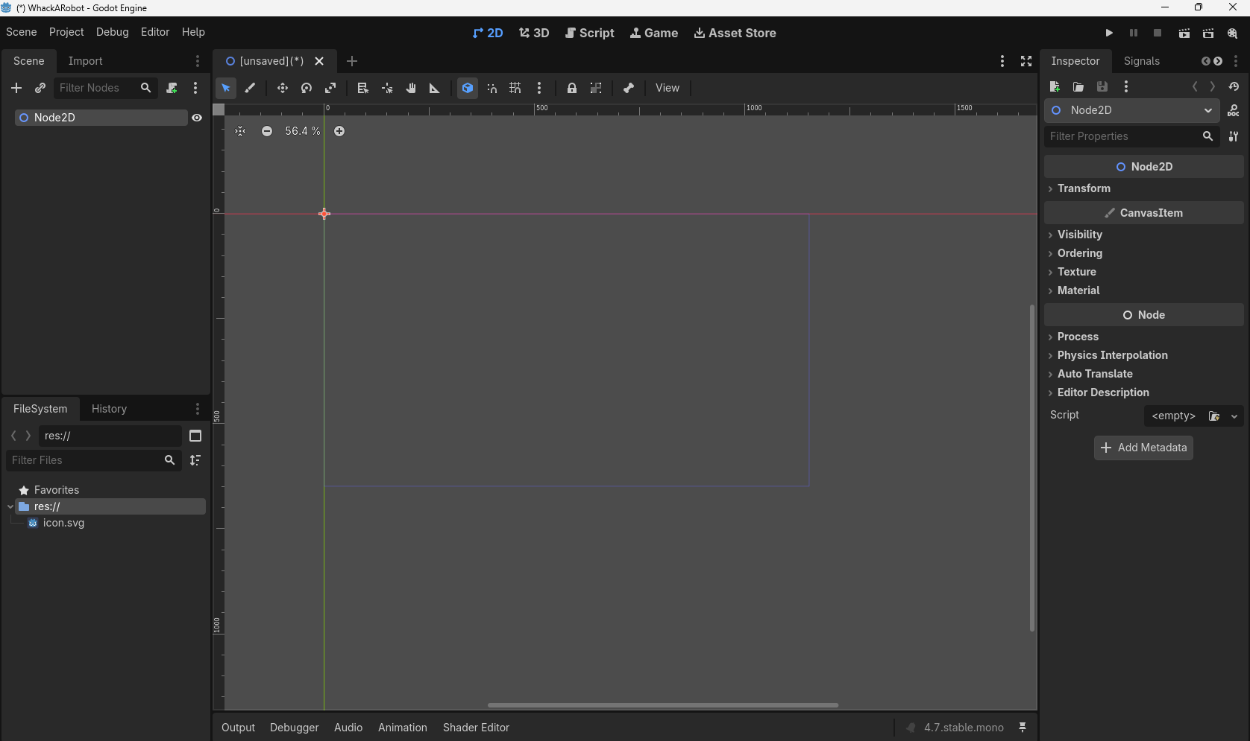
Project created with no issues
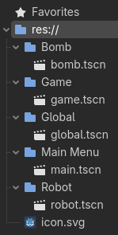
All scenes have been successfully created.
I have decided against creating all the required nodes at this stage because I have not properly planned out how each scene will work yet as that is for future stages.

Testing
Test No. | Description | Test data | Expected Result | Justification | Actual result
1 | Are all the correct scenes there? | Open program editor | All correct scenes have been created | To make sure there will not be any extra scenes that need creating | All intended scenes have been created, organised and are now accessible
2 | Are all the correct nodes there? | Open each scene in program editor | All scenes have the correct nodes | To make sure there will not be any extra nodes that need creating | Have decided against creating nodes at this stage in development
3 | Are all the scenes and nodes in the data dictionary? | Open each scene in program editor and compare to data dictionary | All scenes and nodes are mentioned and categorized in the data dictionary | To make sure that proper organisation has begun and won't need to be created later | The scenes have been successfully added to the data dictionary

Stage 2a: Start menu:

Design:
Because creating the start menu initially only requires two buttons, I believe that using a flow chart will work best. This is because it does not require any complex equations but only some simple logic.
This is the flowchart:
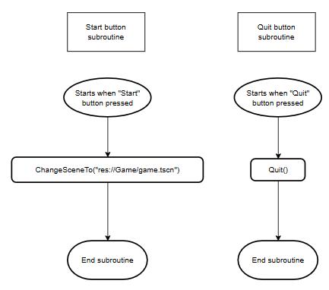

Development:
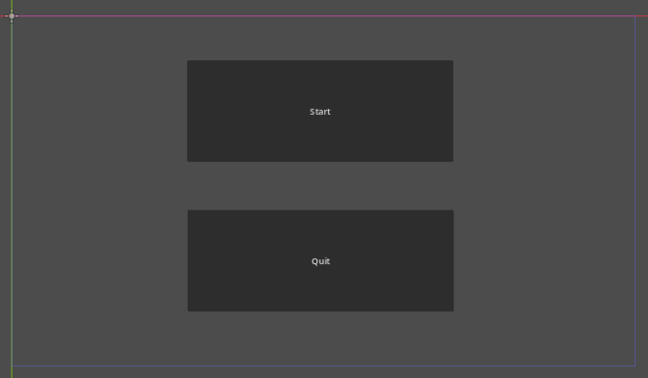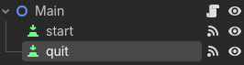 Created two buttons, one for starting the game and one for quitting it. I also attached a c# script to Main, which was saved along with the scene directory.
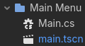
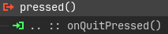
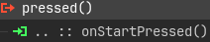 On the signals tab in each button connected the pressed() signal to the code and named the respective subroutine on“Name of button”Pressed.
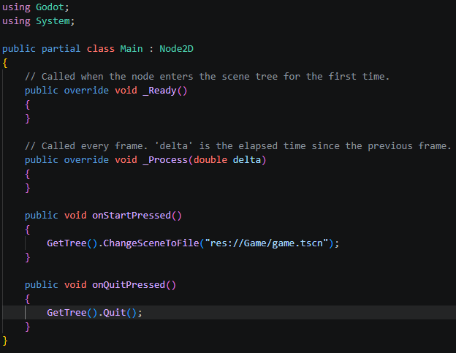 For the code, I followed the logic of the flow charts exactly, only changing it from pseudocode to c#.
After checking the tests, I added the appropriate description of the game's controls.
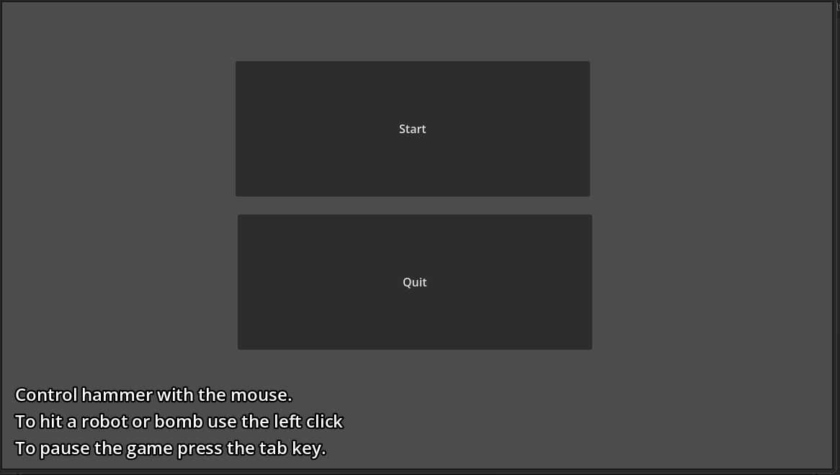

Tests
Test No. | Description | Test data | Expected Result | Justification | Actual result
1a | Can the user enter the game from the “start” button? | Run program and press the “start” button | A scene change to the “game” | To test if the buttons work and that file location of each scene has been recorded properly | Changes scene to game
1b | Can the user quit the game with the “quit” button? | Run program and press the “quit” button | The program closes | To test if the quit button successfully closes the program | The program closes
1c | Is the text describing controls and how to play the game shown? | Run program | The text describing controls and how to play the game is shown | To check if text objects can be displayed correctly. | Text is displayed as intended

Stage 2b: Robot:

Design:
Because the robot doesn’t require any complex programming or calculations, I believe that using a flowchart will be the best option. To get the coordinates for the holes I created a temporary background in paint and inserted it into godot as a sprite2D.
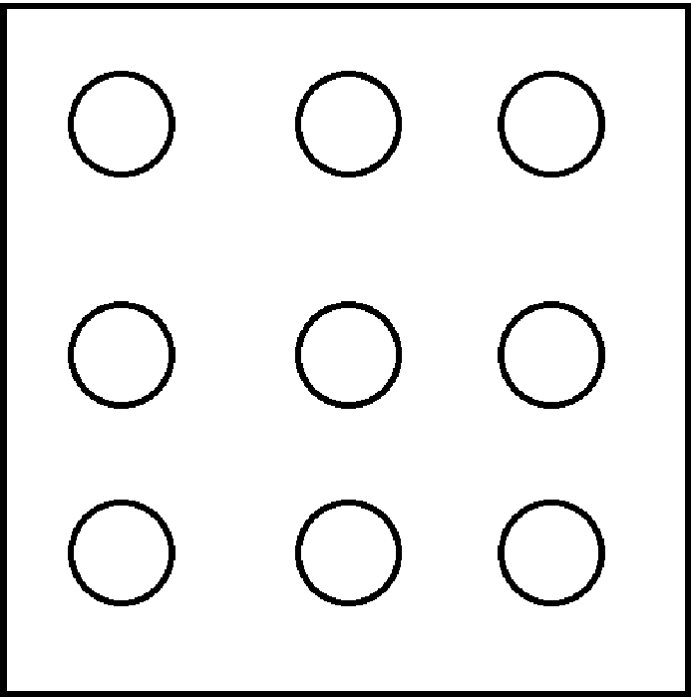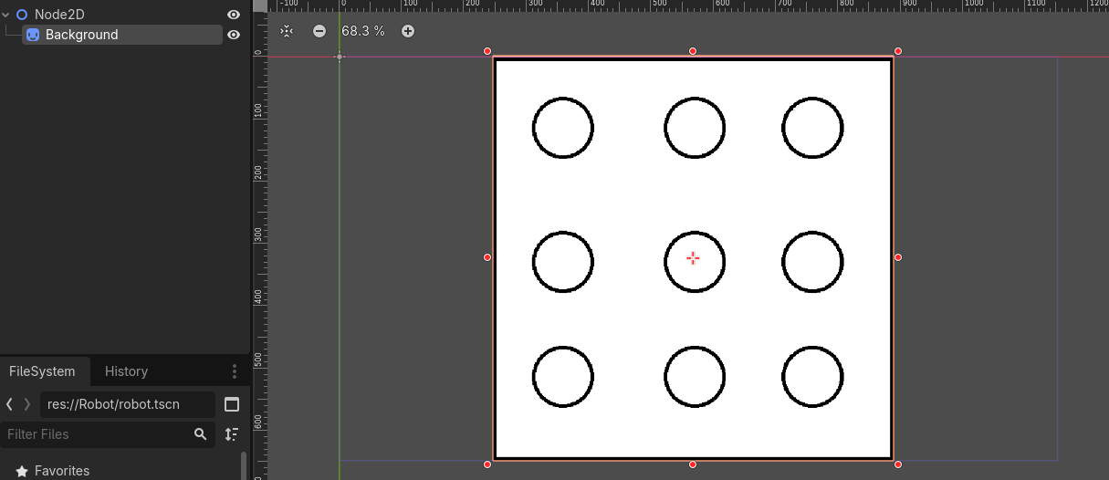

A large majority of the designing had to be done in the game script with creating a spawner that can be used for both robots and bombs and a timer.
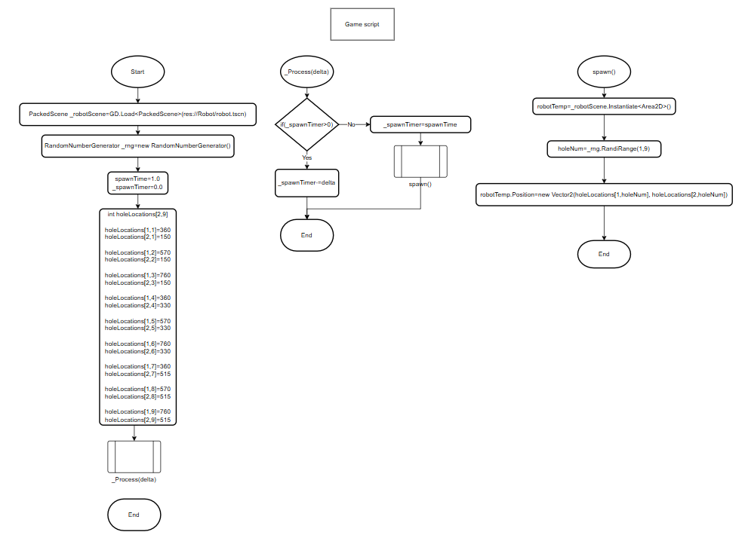
To create a new instance of a robot I also had to create a flow chart for the global scene. This is because “Instantiate” serves as a link between different scenes. 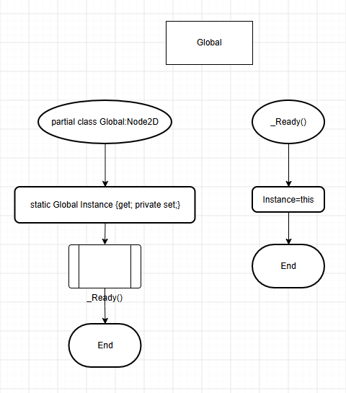
The purpose of robot in this stage is to spawn in a random hole and disappear when clicked. Features like score I intend to add in a later stage.
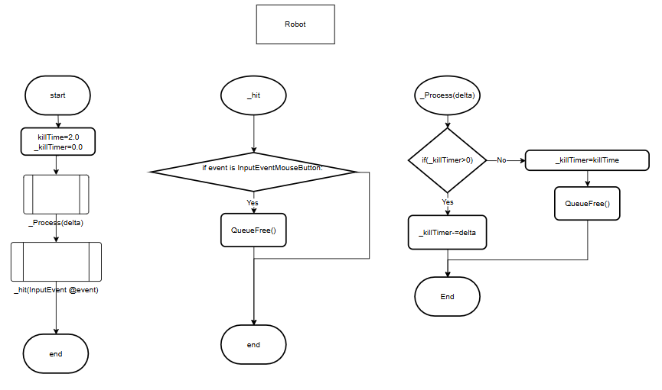

Development
At first, I began development by copying my instructions from the flowchart in my code for the game scene, but I ran into an issue with creating arrays.
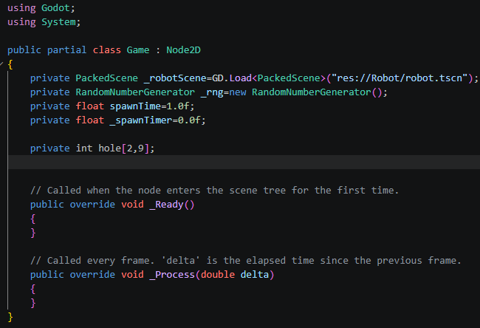
First, I will learn how to implement arrays in godot c#. After looking at relevant tutorials there is no resources on 2DArrays, so I have decided to create two arrays, one being for x coordinates and the other being for y coordinates. This is an updated flowchart containing the changes that needed to be made. 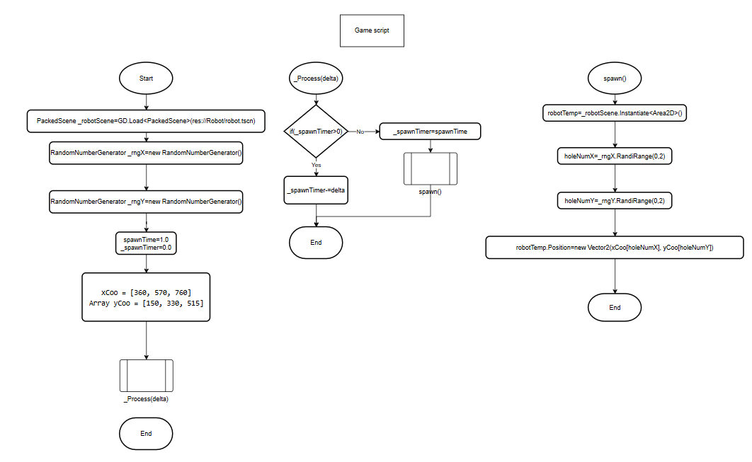
I have now implemented Start and _Process(delta) into code and placed a print function in spawn to test if it can be entered. Upon running it outputted an error requireing the a conversion of delta to be a float.
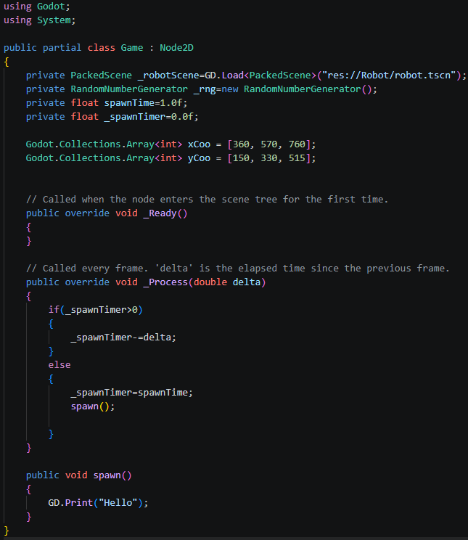
The appropriate changes have now been made. . I then attempted to see if spawn could be entered in test “002. Entering spawn subroutine test”. It did not. I have decided to put print commands throughout the program to see where it enters.
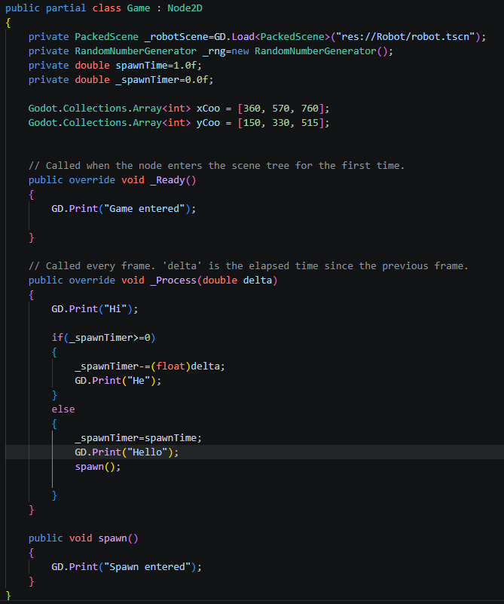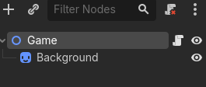 I also realised the script wasn’t connected to the Game node. Results of this test in “003. Entering spawn subroutine test”. Given the amount of outputs was unclear if spawn was actually entered I cleared up the code of GD.Prints.
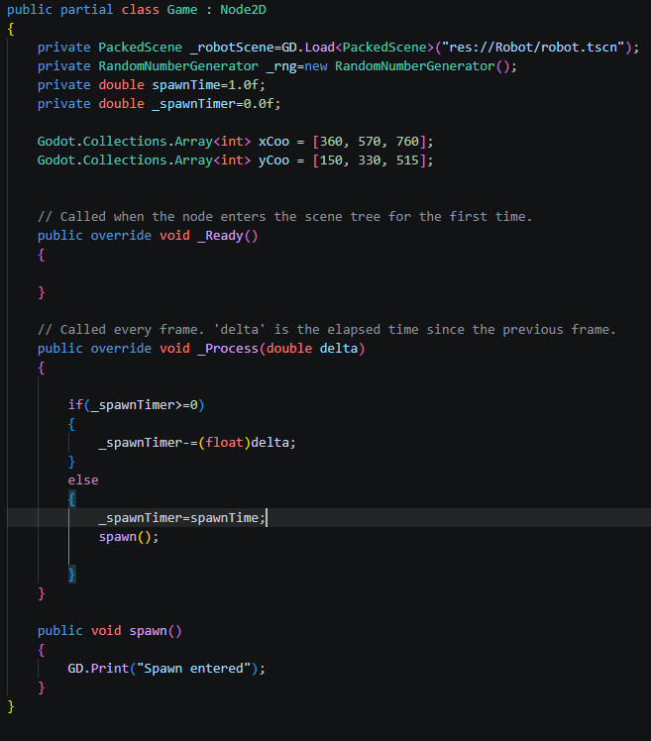 The results were successful and the spawn function has been entered. The test is called “004. Entering spawn subroutine test”.

Data Dictionary

Main

Nodes
start: a button node that changes the scene to Game
quit: a button node that closes the game when pressed
controls: a label node that gives a short description of the game’s controls

Game

Global

Robot

Bomb

Sources
Mouse inputs are from: Mouse and input coordinates — Godot Engine (4.4) documentation in English
Arrays are from Array — Godot Engine (stable) documentation in English

Recordings
Recordings are located at Whack-a-Robot\Tests file and the recordings have the recording number and what it records.

